NM ASSIGNMENT 1

Done by Keshvraaj B B

Data Set Link: [Supermarket sales (kaggle.com)](https://www.kaggle.com/datasets/aungpyaeap/supermarket-sales)

Step 1 : Create a new data module from the uploaded CSV file for visualizing data

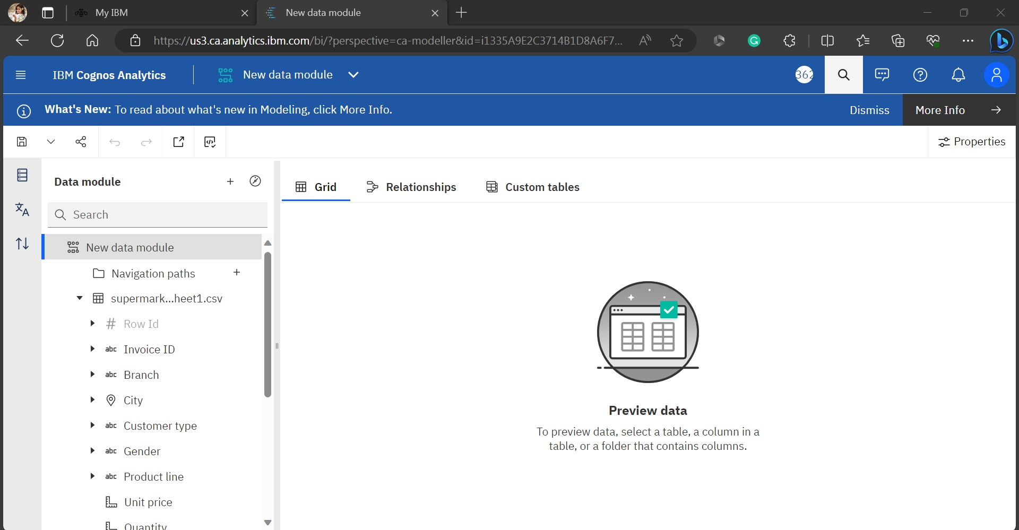

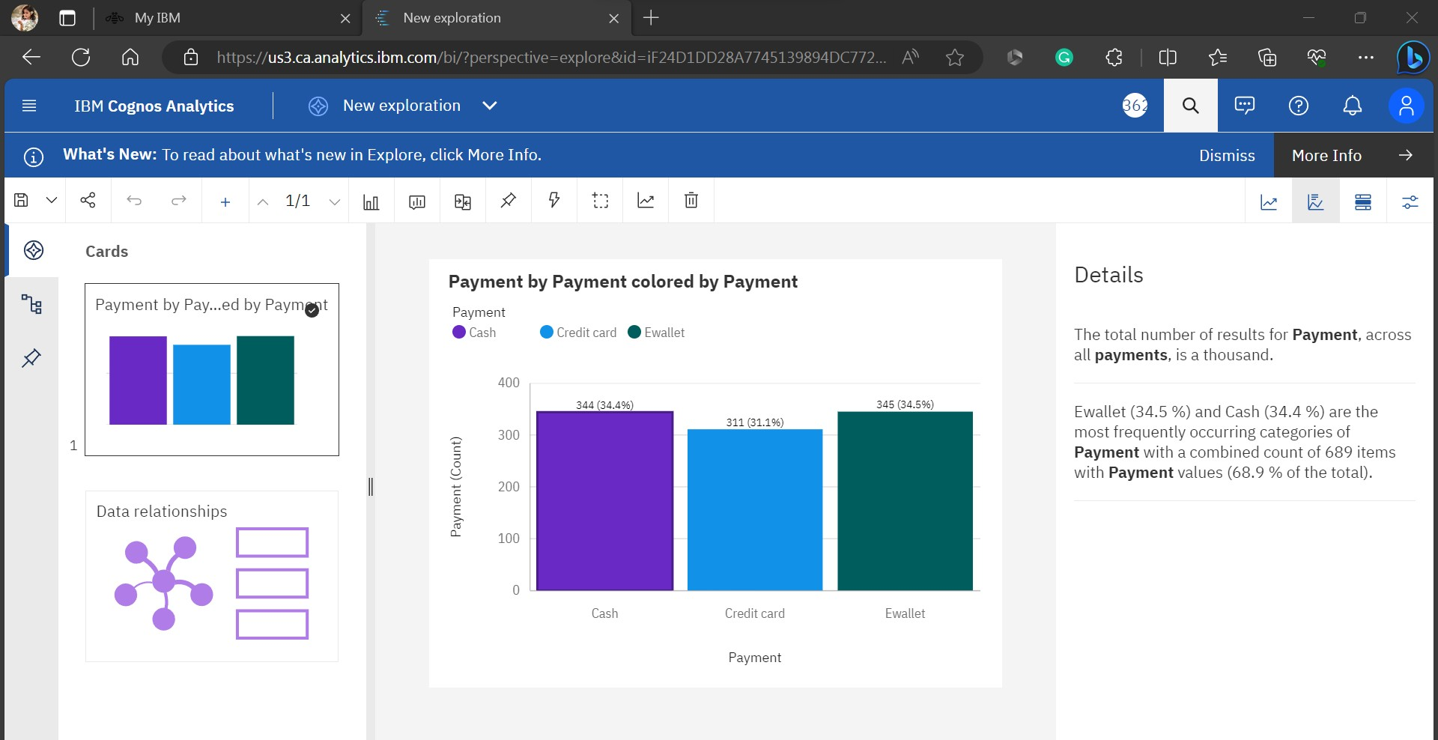Step 2 : Using data module , create more explorations and pin it.

Step 3 : Using the pins, create Dashboard

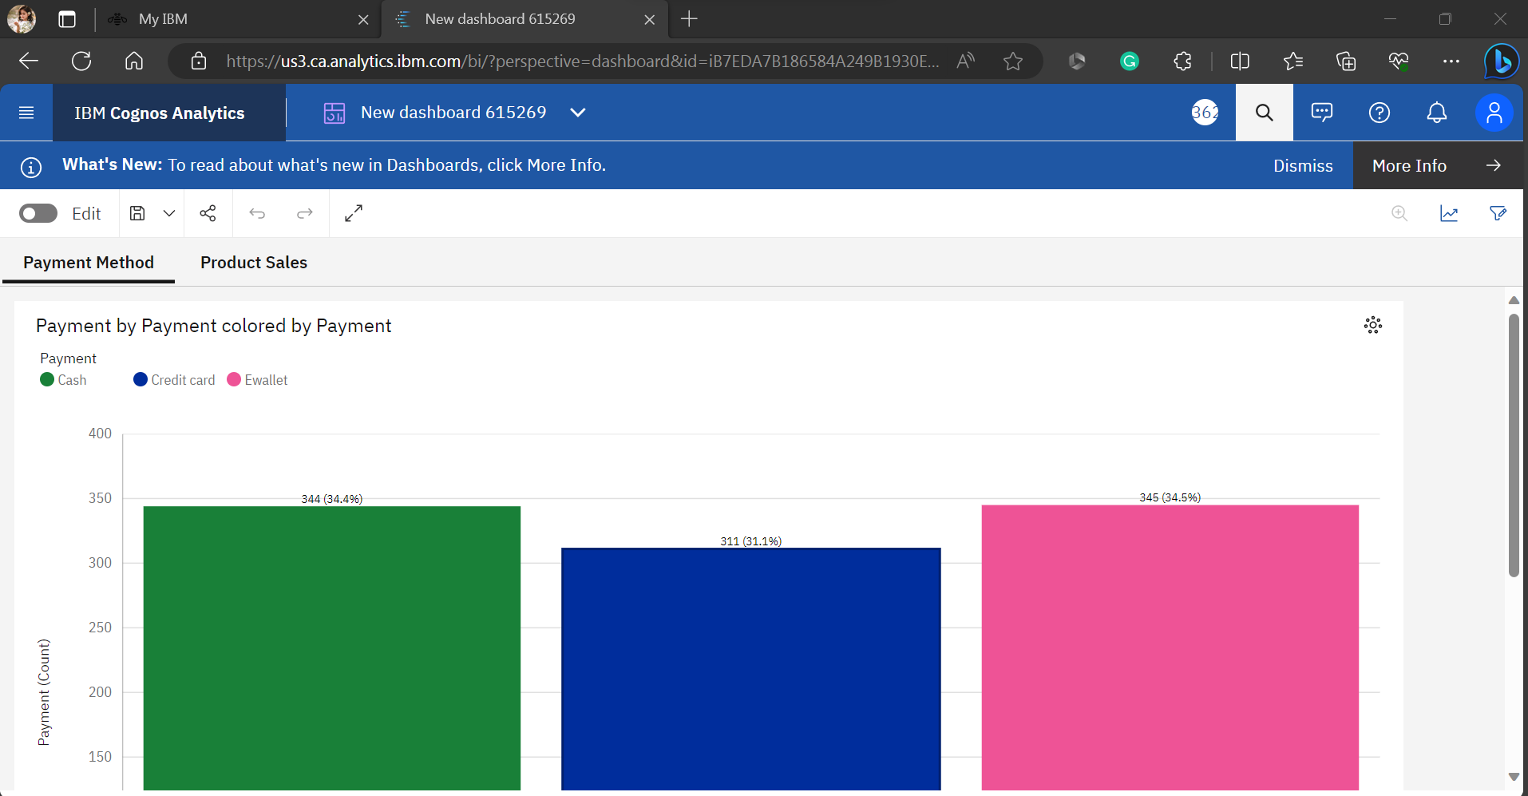

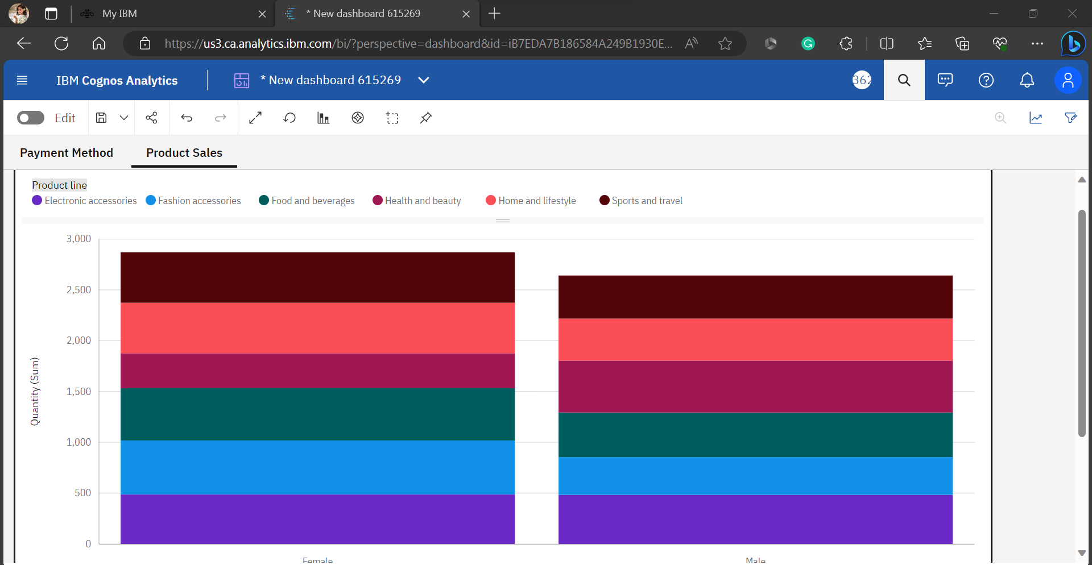

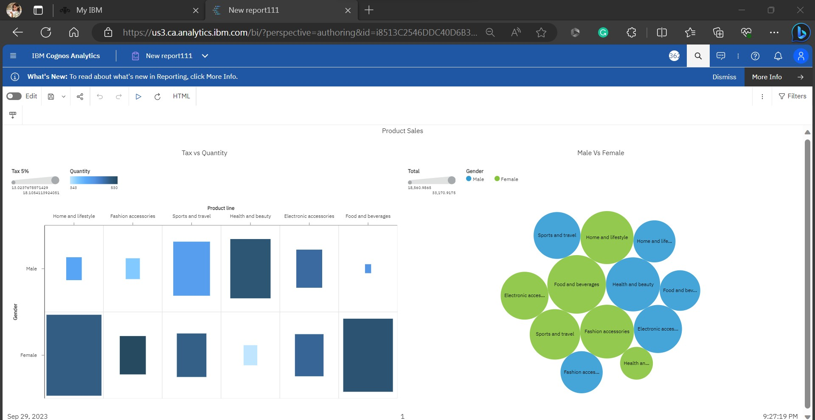Step 4 : After done with that dashboard, Now create a report.

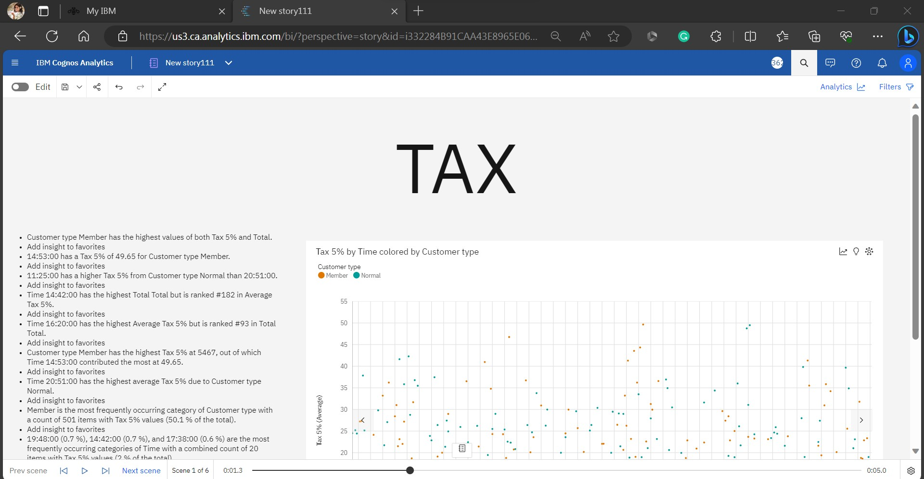Step 5: After done with that report, Create a story to view our visualizations in the form of slides.

